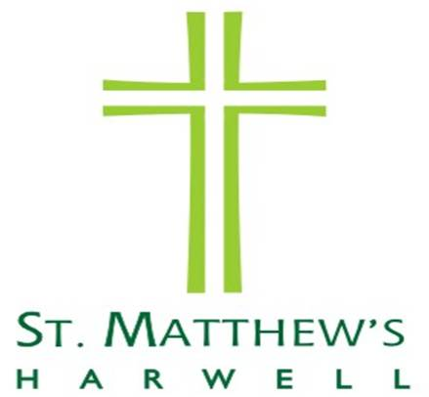

St Matthew’s Church Hall
BOOKING FORM

Date and Day: …………………………………………………………………………...

Time: Start: ……………… End: …………………. Number of hours: ……….

Deposit: £25.00 Paid:…………………………

Cost of Hire: £10.00 per hour Amount Paid: …………………….

Signature for receipt of deposit…………………………………… Date………….

Hirer’s Name: …………………………………………………………………………...

Address: …………………………………………………………………………………

……………………………………………………………………………………………..

Telephone Number: ……………………………………………………………………

Deposit to be returned: Yes/No

Permission given to shred deposit cheque: Yes/No

Hirer’s Signature ……………………………… Date…………………….

Terms and Conditions of Hire
Interpretation – in these Conditions of Hire, Harwell PCC means Harwell Parochial Church Council, and Hirer means the person, persons, group or organisation making application for the use of the Hall.

- BOOKINGS
Application for use of the Hall can be made to Church Hall Bookings Manager, Church Office, St Matthew’s Church, Church Lane Harwell Email: Hall.HCChurches@gmail.com Telephone: 01235 834256
Availability can be checked by accessing our website: www.harwellandchiltonchurches.org.uk
Applications for hiring the Hall will be at the discretion of the PCC. Bookings can be accepted for one off occasions or for regular use. We do not allow hire for parties that require application for an alcohol licence from the Vale of the White Horse e.g. parties where alcohol is sold, or where a bar is run to sell drinks, or events where alcohol is provided as part of a ticket covering a meal with a drink. When the Hall is booked, the individual with responsibility for ensuring these conditions are observed must be named on the booking form. The Hall must be vacated by 11.00pm.

- CHARGES
The minimum charge cost is for 4 hours - £40.00, extra hours are charged at £10.00 an hour. Please allow adequate time within your booking for setting up and clearing up. The total cost of hiring is to be paid on collection of the key from Brian Zimmerman or his deputy, who will meet you at the Hall before your booking. We also charge a £25.00 returnable deposit (to be paid on booking) to cover any breakages or cleaning that may be required, following hiring of the Hall. The deposit will be returned to the hirer after inspection of the Hall – or permission can be given for us to shred your cheque.
PAYMENT CAN BE MADE BY CASH OR CHEQUE, PAYABLE TO “HARWELL PCC”

- NUMBERS
The maximum number of people allowed in the Hall is 80. However, we are only able to seat 40 to eat at tables.

- CONSIDERATION OF NEIGHBOURS
Please remember that this is a residential area. Windows in the main Hall are non-opening.
The Hirer is responsible for the behaviour of all persons using the premises, ensuring that people leave in an orderly manner and for the proper supervision of car parking arrangements so as to avoid obstruction.
Emergency services must be able to access houses in the area.

- INSURANCE AND CHILD PROTECTION.
Please note that you are responsible for observing all regulations stipulated by the Licensing Authority, the Fire Authority and the Local Authority. Child Protection Policies are the responsibility of the people/organisations hiring the hall for activities involving children and vulnerable adults. The person responsible for the hire of the Hall must ensure that the Hall is left secure and that both top and bottom locks on the door have been locked.

- CLEANING AND LEAVING THE BUILDING
Please take all your rubbish, including recycling, home with you. The Hall bins do not have the capacity to hold a large amount over a fortnightly period. Please leave the Hall clean and tidy and sweep the floor. Replace any tables and chairs to the store cupboard. Please ensure all lights are switched off before leaving. This includes the outside lights, but these can be set on for a further five minutes, so that you can find your way, by using the push button situated at the end of the rows of coat pegs.

CANCELLATION POLICY
In the event of the Hirer requesting cancellation of the booking, we ask for a week’s notice to ensure repayment of any monies paid. In the case of notice of cancellation less than one week, repayment will be at the discretion of the Parochial Church Council. Should the Hall be rendered unfit for use, all fees and deposits paid will be returned in full.

